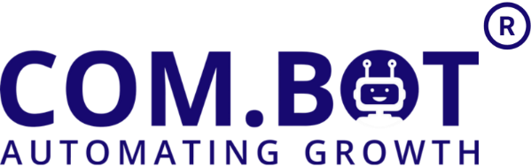
Meta Business Partner
501,Trinity Orion, Vesu Main Road, Surat, Gujarat, India - 395007 | GSTIN - 24DUKPS5774J1ZV
Email :- Sales@Com.Bot | Ph :- +91 83201 86467
🚀 Plan: LifeTime Whitelabel.

White Label License: $410 + Gst ( Lifetime)
- No user limit
- Complete white-label platform setup
- Custom domain configuration
- Branding customization
- Advanced crm and channel section online group training
Per User (Starter Plan) $1 (per user/month)
- Unlimited WhatsApp Channels
- 1 Million Contacts
- Do It Yourself Bot Builder
- Support - WABA And CRM ~ SLA 3 Days
- 10 Messages / Second Speed Limit

✅ Inclusion For Each Customer Account
CRM
- CRM access included
- Unlimited WhatsApp Channels
- 1 Million Contacts
- 5 GB Data Storage

Ecommerce
- 1 WhatsApp Store
- 100 Products
- 100 Orders / month
- 100 Abandoned Cart Records

Bots
- Do-It-Yourself Bot Builder
- External Actions / Apps Not Included

Support
- WABA & CRM SLA: 3 Days
- 10 Messages/Second Speed Limit

Per User (Wa Bulk API-Only Plan) FREE till Dec 2026 (per user/month)
- 5 WhatsApp Channels
- CRM & LIve Chat
- 1 Million Contacts
- No Bot Builders & Automation
- Support - WABA And CRM ~ SLA 3 Days
- 10 Messages / Second Speed Limit

Add-Ons (Optional)
Add-On | Price | Details
External Actions | $3/month | 5000 executions per month
Team Member | $1/month | Per additional team member
Instagram / Messenger / RCS | $50/month | Per additional social channel
Calendars Bot | $50/month | Calendar management and scheduling
QR Ticket | $0.02/ticket | Per dynamic QR ticket generated
Dynamic Image  Ai Modelling | ₹0.5/image  $1/per credit | Per image generated dynamically  Credit used for input or output image.
🛠️ Support & Training Services

Service | Rate | Description
Onboarding Support | $14/hour | Sub-account based onboarding setup
Basic Training | $14/hour | CRM, Inbox, and WhatsApp Business training
Ecommerce Setup | $23/hour | Product, orders, cart integration and setup
Bot Training | $23/hour | Building basic bots, logic, flow design
Automation Training | $23/hour | Training for CRM workflows and automations

📌 Important Notes
- All prices are subject to annual revision.
- Conversation charges will be billed as per Meta’s official rates.
- Taxes extra as applicable as per Indian Law.
- Additional Add-ons & upgrades will be made available as our platform evolves.
- Only Cloudflare DNS is supported. Domains using other DNS providers must be migrated to Cloudflare.
- Partner panel setup is self-managed. A step-by-step video guide will be provided. Only one onboarding session is included for 1st number onboarding.

